EXPT: 1
DATE:
APPLICATION USING CLASSES AND OBJECTS
AIM:

To develop a java application to generate the electricity bill using classes and objects.

ALGORITHM:
- Start the program. Type the program in notepad and store with class name and with
.java extension.
- Create a class named EBbillCalculation with the necessary variables.
- Get input for consumer number, name, previous and current meter readings.
- Calculate units consumed as current reading minus previous reading.
- Ask the user to select the type of connection: Domestic or Commercial.
- Based on the type, calculate the bill using slab-wise rates.
- Domestic: ₹1/unit up to 100, ₹2.50/unit for next 100, ₹4/unit up to 500 and ₹6/unit beyond 500.
- Commercial: ₹2/unit up to 100, ₹4.50/unit for next 100, ₹6/unit up to 500 and ₹7/unit beyond 500.
- Display consumer details, units consumed, and the total bill amount.
- Compile and run the program using the following commands in command prompt:
To compile: javac ex1.java
To run: java ex1
- End the program.
PROGRAM:

import java.io.*;
import java.util.*;
class EBbillCalculation {
int cno;
String cname;
int pm_reading, cm_reading, units;
double billpay;
void getdetails() {
Scanner in = new Scanner(System.in);
System.out.println("Enter the Consumer No:");
cno = in .nextInt();
System.out.println("Enter the Consumer Name:");
cname = in .next();
System.out.println("Enter the Previous Month Reading:");
pm_reading = in .nextInt();
System.out.println("Enter the Current Month Reading:");
cm_reading = in .nextInt();
units = cm_reading - pm_reading;
System.out.println("Choose the type of EB Connection 1.Domestic connection 2. Commercial connection");
int ch = in .nextInt();
switch (ch) {
case 1:
Domestic_Calculation(units);
break;
case 2:
Commercial_Calculation(units);
break;
}
}
void Domestic_Calculation(int units) {
billpay = 0;
if (units <= 100) {
billpay = units * 1.00;
} else if (units > 100 && units <= 200) {
billpay = 100 * 1.00 + (units - 100) * 2.50;
} else if (units > 200 && units <= 500) {
billpay = 100 * 1.00 + 200 * 2.50 + (units - 200) * 4.00;
} else if (units > 500) {
billpay = 100 * 1.00 + 200 * 2.50 + 500 * 4.00 + (units - 500) * 6.00;
}
show();
System.out.println("Amount to be Paid : " + billpay);
}
void Commercial_Calculation(int units) {
billpay = 0;
if (units <= 100) {
billpay = units * 2.00;
} else if (units > 100 && units <= 200) {
billpay = 100 * 2.00 + (units - 100) * 4.50;
} else if (units > 200 && units <= 500) {
billpay = 100 * 2.00 + 200 * 4.50 + (units - 200) * 6.00;
} else if (units > 500) {
billpay = 100 * 2.00 + 200 * 4.50 + 500 * 6.00 + (units - 500) * 7.00;
}
show();
System.out.println("Amount to be Paid : " + billpay);
}
public void show() {
System.out.println("Customer Number : " + cno);
System.out.println("Customer Name : " + cname);

System.out.println("Units Consumed : " + units);
}
}
class ex1 {
public static void main(String[] args) {
EBbillCalculation eb = new EBbillCalculation();
eb.getdetails();
}
}

OUTPUT:

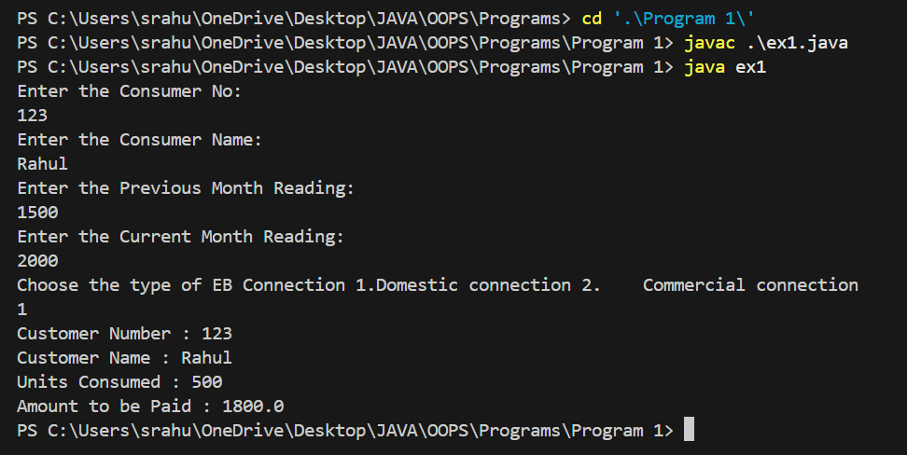

RESULT:

Thus, the java application for generating the electricity bill is created and executed successfully.

EXPT: 2 a)
DATE:

APPLICATION USING PACKAGES
AIM:

To develop a java application to implement currency converter, distance converter and time converter using the concept of packages.

ALGORITHM:

- Start the program.
- Create three packages:
- currencyconversion which contains ex2acurrency class with methods for currency conversion.
- distanceconversion which contains ex2distance class with methods for distance conversion.
- timeconversion which contains ex2timer class with methods for time conversion.
- In each class, define appropriate methods for conversion.
- Create a converter class with main method.
- Import the packages and create objects for each class.
- Display a menu to the user with conversion options.
- Based on the user’s choice, call the corresponding method.
- Repeat until the user chooses to exit.
- End the program.

PROGRAM:

currency.java:
package currencyconversion;
import java.util.*;
public class ex2acurrency {
double inr, usd;
double euro, yen;
Scanner in = new Scanner(System.in);
public void dollartorupee() {
System.out.println("Enter dollars to convert into Rupees:");
usd = in .nextInt();
inr = usd * 67;
System.out.println("Dollar =" + usd + "equal to INR=" + inr);
}
public void rupeetodollar() {
System.out.println("Enter Rupee to convert into Dollars:");
inr = in .nextInt();
usd = inr / 67;
System.out.println("Rupee =" + inr + "equal to Dollars=" + usd);
}
public void eurotorupee() {
System.out.println("Enter euro to convert into Rupees:");
euro = in .nextInt();
inr = euro * 79.50;
System.out.println("Euro =" + euro + "equal to INR=" + inr);
}
public void rupeetoeuro() {
System.out.println("Enter Rupees to convert into Euro:");
inr = in .nextInt();
euro = (inr / 79.50);
System.out.println("Rupee =" + inr + "equal to Euro=" + euro);
}
public void yentorupee() {
System.out.println("Enter yen to convert into Rupees:");

yen = in .nextInt();
inr = yen * 0.61;
System.out.println("YEN=" + yen + "equal to INR=" + inr);
}
public void rupeetoyen() {
System.out.println("Enter Rupees to convert into Yen:");
inr = in .nextInt();
yen = (inr / 0.61);
System.out.println("INR=" + inr + "equal to YEN" + yen);
}}

distance.java:
package distanceconversion;
import java.util.*;
public class ex2distance {
double km, m, miles;
Scanner sc = new Scanner(System.in);
public void kmtom() {
System.out.print("Enter in km ");
km = sc.nextDouble();
m = (km * 1000);
System.out.println(km + "km" + "equal to" + m + "metres");
}
public void mtokm() {
System.out.print("Enter in meter ");
m = sc.nextDouble();
km = (m / 1000);
System.out.println(m + "m" + "equal to" + km + "kilometres");
}
public void milestokm() {
System.out.print("Enter in miles");
miles = sc.nextDouble();
km = (miles * 1.60934);
System.out.println(miles + "miles" + "equal to" + km + "kilometres");
}

public void kmtomiles() {
System.out.print("Enter in km");
km = sc.nextDouble();
miles = (km * 0.621371);
System.out.println(km + "km" + "equal to" + miles + "miles");
}}

timer.java:
package timeconversion;
import java.util.*;
public class ex2timer {
int hours, seconds, minutes;
int input;
Scanner sc = new Scanner(System.in);
public void secondstohours() {
System.out.print("Enter the number of seconds: ");
input = sc.nextInt();
hours = input / 3600;
minutes = (input % 3600) / 60;
seconds = (input % 3600) % 60;
System.out.println("Hours: " + hours);
System.out.println("Minutes: " + minutes);
System.out.println("Seconds: " + seconds);
}
public void minutestohours() {
System.out.print("Enter the number of minutes: ");
minutes = sc.nextInt();
hours = minutes / 60;
minutes = minutes % 60;
System.out.println("Hours: " + hours);
System.out.println("Minutes: " + minutes);
}
public void hourstominutes() {

System.out.println("enter the no of hours");
hours = sc.nextInt();
minutes = (hours * 60);
System.out.println("Minutes: " + minutes);
}
public void hourstoseconds() {
System.out.println("enter the no of hours");
hours = sc.nextInt();
seconds = (hours * 3600);
System.out.println("Minutes: " + seconds);
}
}

converter.java:
import java.util.*;
import java.io.*;
import currencyconversion.ex2acurrency;
import distanceconversion.ex2distance;
import timeconversion.ex2timer;
class converter {
public static void main(String args[]) {
Scanner s = new Scanner(System.in);
int choice, ch;
ex2acurrency c = new ex2acurrency();
ex2distance d = new ex2distance();
ex2timer t = new ex2timer();
do {
System.out.println("1.dollar to rupee ");
System.out.println("2.rupee to dollar ");
System.out.println("3.Euro to rupee ");
System.out.println("4..rupee to Euro ");
System.out.println("5.Yen to rupee ");
System.out.println("6.Rupee to Yen ");
System.out.println("7.Meter to kilometer ");
System.out.println("8.kilometer to meter ");
System.out.println("9.Miles to kilometer ");
System.out.println("10.kilometer to miles");

System.out.println("11.Hours to Minutes");
System.out.println("12.Hours to Seconds");
System.out.println("13.Seconds to Hours");
System.out.println("14.Minutes to Hours");
System.out.println("Enter ur choice");
choice = s.nextInt();
switch (choice) {
case 1:
{
c.dollartorupee();
break;
}
case 2:
{
c.rupeetodollar();
break;
}
case 3:
{
c.eurotorupee();
break;
}
case 4:
{
c.rupeetoeuro();
break;
}
case 5:
{
c.yentorupee();
break;
}
case 6:
{
c.rupeetoyen();
break;
}
case 7:
{
d.mtokm();
break;

}
case 8:
{
d.kmtom();
break;
}
case 9:
{
d.milestokm();
break;
}
case 10:
{
d.kmtomiles();
break;
}
case 11:
{
t.hourstominutes();
break;
}
case 12:
{
t.hourstoseconds();
break;
}
case 13:
{
t.secondstohours();
break;
}
case 14:
{
t.minutestohours();
break;
}
}
System.out.println("Enter 0 to quit and 1 to continue ");
ch = s.nextInt();
} while (ch == 1);
}
}

OUTPUT:

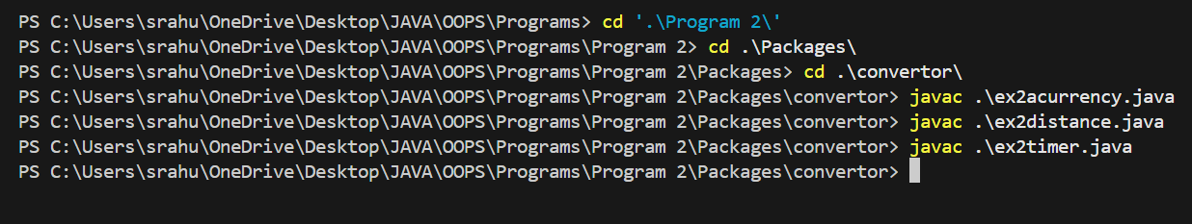
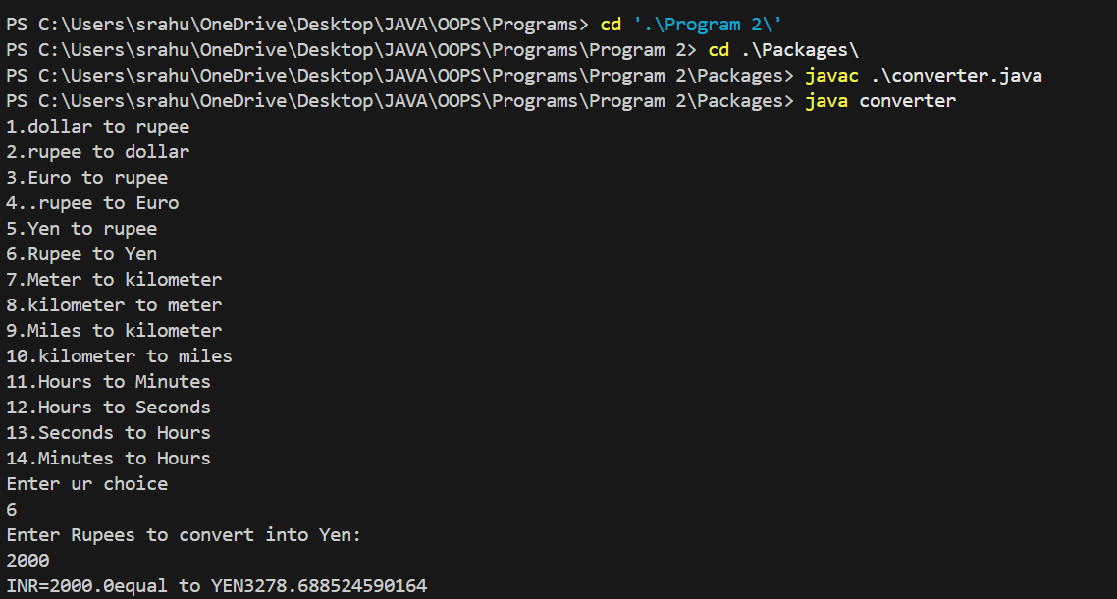
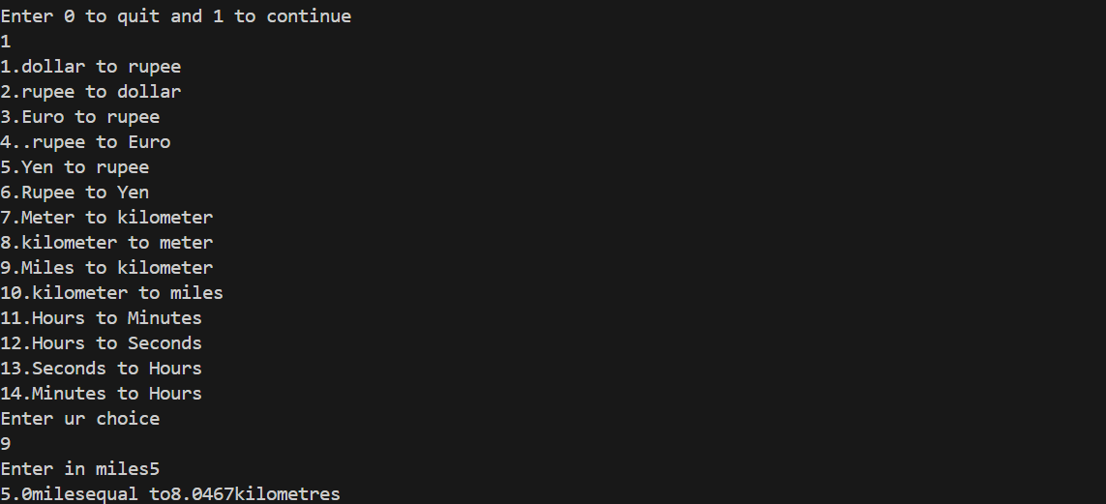
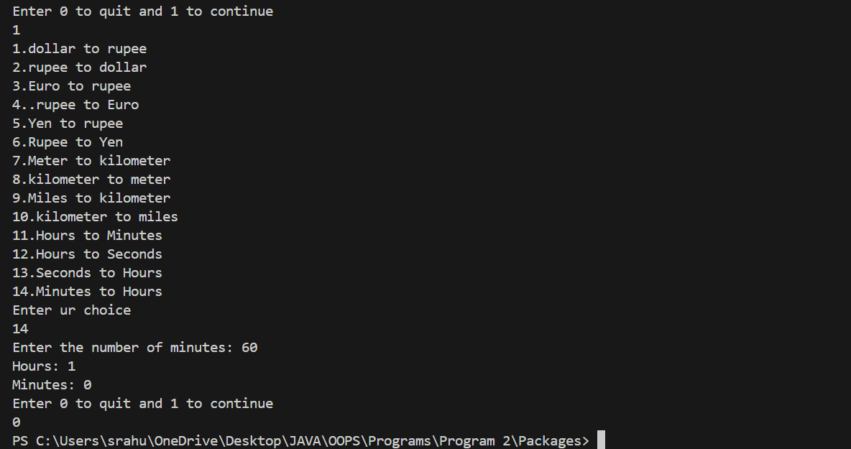

RESULT:

Thus, the java application to implement currency converter, distance converter and time converter was implemented and executed successfully.

EXPT: 3
DATE:
APPLICATION USING INHERITANCE

AIM:

To develop a java application to generate pay slip for different category of employees using the concept of inheritance.

ALGORITHM:

- Start the program.

- Create a base class employee with attributes: name, ID, address, email, and mobile number.
- Add methods to get and display employee details.

- Create subclasses named programmer, asstprofessor, associateprofessor, and professor extending employee.
- In each subclass, input basic pay and calculate DA (97%), HRA (10%), PF (12%), and club fund (0.1%) of basic pay.
- Calculate gross salary and net salary, then display the pay slip.

- In the main method, create the objects for the inherited classes and invoke the necessary methods to display the Pay slip. show a menu to select employee type.
- Based on the choice, create an object, get details, and generate the pay slip.

- Repeat until the user chooses to exit.

- End the program.

PROGRAM:

import java.util.*;

class Employee {
Scanner scan = new Scanner(System.in);

int eid;
String ename, eemail;

void details() {
System.out.println("Enter the ID of Employee : ");
eid = scan.nextInt();
scan.nextLine(); // consume leftover newline
System.out.println("Enter the Name of Employee : ");
ename = scan.nextLine();
System.out.println("Enter the Mail ID of Employee : ");
eemail = scan.nextLine();
}

void salary_calculation(double basicpay, double allowanceRate) {
double da, hra, p_fund, gross_salary, net_salary;
da = basicpay * allowanceRate;
hra = basicpay * 0.80;
p_fund = basicpay * 0.70;
gross_salary = basicpay + da + hra;
net_salary = gross_salary - p_fund;
System.out.println("Gross Salary: " + gross_salary);
System.out.println("Net Salary: " + net_salary);
}

void showDetails() {
System.out.println("\n------------------------------------------");
System.out.println("Employee ID : " + eid);
System.out.println("Employee Name : " + ename);
System.out.println("Employee Email ID : " + eemail);
System.out.println("\n------------------------------------------");
}
}

class HR extends Employee {

void Hr_Details() {
double basicpay;
details();
System.out.println("Enter the Basic pay of HR(80% Allowance) : ");
basicpay = scan.nextDouble();
salary_calculation(basicpay, 0.80);
showDetails();
}
}

class SeniorProgrammer extends Employee {

void SP_details() {
double basicpay;
details();
System.out.println("Enter the Basic pay of Senior Programmer(50% Allowance) : ");
basicpay = scan.nextDouble();
salary_calculation(basicpay, 0.50);
showDetails();
}
}

class Fresher extends Employee {

void fresher_details() {
double basicpay;
details();
System.out.println("Enter the Basic pay of Fresher(10% Allowance) : ");
basicpay = scan.nextDouble();
salary_calculation(basicpay, 0.10);
showDetails();
}
}

public class Main {

public static void main(String args[]) {
Scanner scan = new Scanner(System.in);
int ch;
System.out.println("\nChoose the Employee Designation Option : ");
System.out.println("1.HR\n2.SENIOR PROGRAMMER\n3.FRESHER");
System.out.println("Choose your Option : ");
ch = scan.nextInt();

switch (ch) {
case 1:
System.out.println("Give the Necessary Details of HR");
HR hr = new HR();
hr.Hr_Details();
break;
case 2:
System.out.println("Give the Necessary Details of Senior Programmer");
SeniorProgrammer sp = new SeniorProgrammer();
sp.SP_details();
break;
case 3:
System.out.println("Give the Necessary Details of Fresher");
Fresher fr = new Fresher();
fr.fresher_details();
break;
default:
System.out.println("Enter the Correct Option");
break;
}

scan.close();
}
}

OUTPUT:

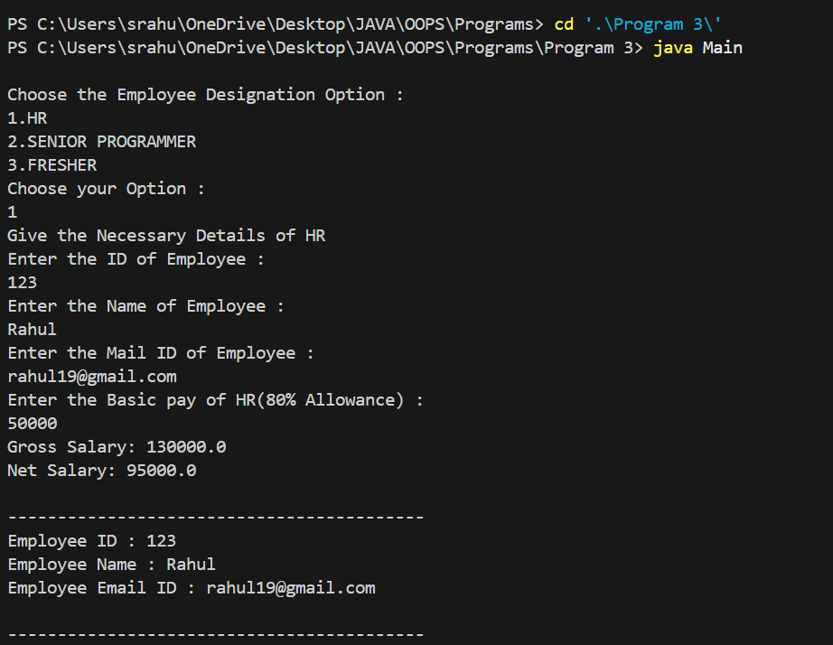

RESULT:

Thus, the java application to generate pay slips for different categories of employees was implemented using inheritance and the program was executed successfully.
EXPT: 4
DATE:
ABSTRACT CLASS

AIM:

To write a java program to create an abstract class named Shape .

ALGORITHM:

- Start the program.
- Define an abstract class Shape with two variables and an abstract method Area().
- Create subclasses: Rectangle, Triangle, and Circle, each extending Shape.
- In each subclass, implement the Area() method to compute and display the area.
- In the main() method:
  - Create an object of Rectangle and call Area().
  - Create an object of Triangle and call Area().
  - Create an object of Circle and call Area().
- Each object will execute its version of the Area() method demonstrating polymorphism.
- End the program.

PROGRAM:

import java.io.*;
import java.util.*;
abstract class Shape {
String name;
Shape(String name) {
this.name = name;
}
abstract double calculateArea();
}
class Circle extends Shape {
double radius;
Circle(double radius) {
super("Circle");
this.radius = radius;
}
public double calculateArea() {
return Math.PI * radius * radius;
}
}
class Rectangle extends Shape {
double length;
double breadth;

Rectangle(double length, double breadth) {
super("Rectangle");
this.length = length;
this.breadth = breadth;
}
public double calculateArea() {
return length * breadth;
}
}
class Square extends Shape {
double side;
Square(double side) {
super("Square");
this.side = side;
}
public double calculateArea() {
return side * side;
}
}
public class main {
public static void main(String args[]) {
Circle cr = new Circle(5);
Rectangle rec = new Rectangle(5, 5);
Square sq = new Square(5);
System.out.println("Area of Circle : " + cr.calculateArea());
System.out.println("Area of Rectangle : " + rec.calculateArea());
System.out.println("Area of Square : " + sq.calculateArea());
}
}

OUTPUT:

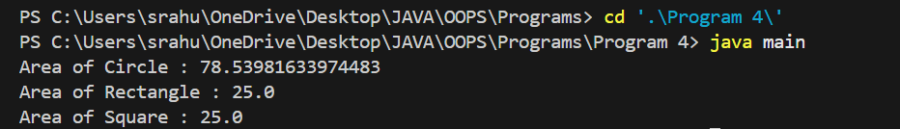

RESULT:

Thus, the program for abstract class has been written and executed successfully.

EXPT: 5
DATE:
MULTIPLE INHERITANCE USING INTERFACE

AIM:

To write a java program that demonstrates Multiple Inheritance using Interface.

ALGORITHM:

- Start the program.

- Create a base class employee with attributes: name, ID, address, email, and mobile number.
- Add methods to get and display employee details.

- Create subclasses named programmer, asstprofessor, associateprofessor, and professor extending employee.
- In each subclass, input basic pay and calculate DA (97%), HRA (10%), PF (12%), and club fund (0.1%) of basic pay.
- Calculate gross salary and net salary, then display the pay slip.

- In the main method, create the objects for the inherited classes and invoke the necessary methods to display the Pay slip. show a menu to select employee type.
- Based on the choice, create an object, get details, and generate the pay slip.

- Repeat until the user chooses to exit.

- End the program.

PROGRAM:

interface A{
void meth1();
}

interface B{
void meth2();
}

class Demo implements A,B{
public void meth1(){
System.out.println("Implemented Method 1 of interface A");
}

public void meth2(){
System.out.println("Implemented Method 2 of interface B");
}
}

class main{
public static void main(String args[]){
Demo obj = new Demo();
obj.meth1();
obj.meth2();
}
}}
OUTPUT:
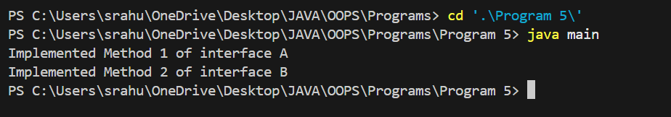

RESULT:
Thus, the program to demonstrate multiple inheritance using interface has been written and executed successfully.
EXPT: 6
DATE:
STRING AND STRINGBUFFER CLASS
AIM:

To write a java program to perform string operations using String and StringBuffer class.

ALGORITHM:
- Start the program.

- Read a string from the user.

- Find length using length() and display.

- Convert to uppercase and lowercase using toUpperCase() and toLowerCase().
- Concatenate another string using concat() and display.
- Reverse the string using StringBuffer and reverse() method.

- Insert/Delete/Replace characters using StringBuffer methods if needed. Based on the choice, create an object, get details, and generate the pay slip.

- Display all results.

- End the program.

PROGRAM:

public class StringOperationsDemo {
public static void main(String[] args) {

String str1 = "Hello";
String str2 = "World";
String result = str1 + " " + str2;
System.out.println("Concatenated String: " + result);
System.out.println("Length of result string: " + result.length());
System.out.println("Character at index 2: " + result.charAt(2));
System.out.println("Substring from index 2 to 6: " + result.substring(2, 6));
System.out.println("Uppercase: " + result.toUpperCase());
System.out.println("Lowercase: " + result.toLowerCase());
System.out.println("Index of 'g': " + result.indexOf('g'));
StringBuffer sb = new StringBuffer("Hello");
sb.append(" World");
System.out.println("\nAfter append: " + sb);
sb.insert(6, "Java ");
System.out.println("After insert: " + sb);
sb.replace(6, 10, "Wonderful");
System.out.println("After replace: " + sb);
sb.delete(6, 13);
System.out.println("After delete: " + sb);
sb.reverse();
System.out.println("After reverse: " + sb);
}
}

OUTPUT:

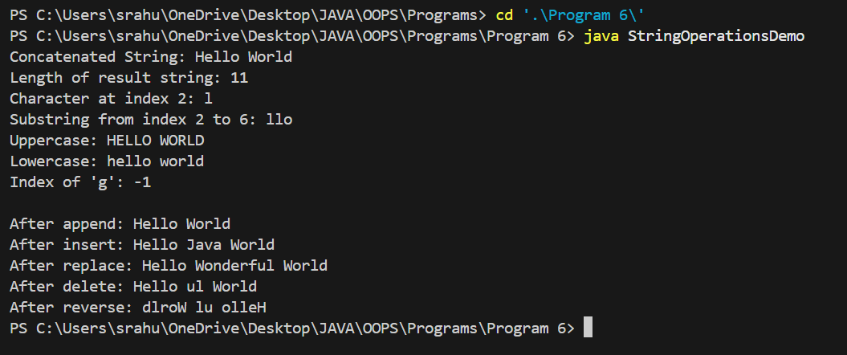

RESULT:

Thus, the program to perform string operations using String and StringBuffer class has been written and executed successfully.
EXPT: 7
DATE:

USER DEFINED EXCEPTION HANDLING
AIM:

To write a Java program to implement user defined exception handling.

ALGORITHM:
- Start the program.

- Create a custom exception class extending Exception with a constructor to accept an error message and override toString() to display it.

- In the main method begin a try block and print a message.

- Throw a new object of the custom exception with an error message.
- Catch the thrown exception in a catch block
- Print the catch block message and the exception details

- End the program.

PROGRAM:

package example1;

class MyException extends Exception{
String str1;
MyException(String str2) {
str1=str2;
}
public String toString(){
return ("MyException Occurred: "+str1) ;
}
}
public class Example1 {

public static void main(String[] args)

{
try{
System.out.println("Starting of try block");
// I'm throwing the custom exception using throw
throw new MyException("This is My error Message");
}
catch(MyException exp){
System.out.println("Catch Block") ;
System.out.println(exp) ;
}
}

}

OUTPUT:

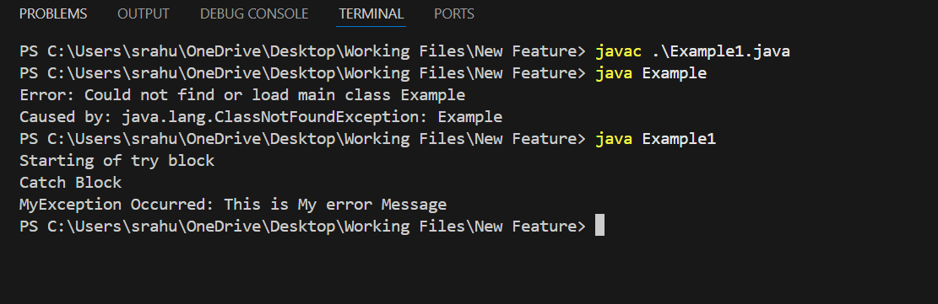

RESULT:
Thus, the program user defined exception handling has been written and executed successfully.

EXPT: 8
DATE:

FILE OPERATIONS
AIM:
To write a Java program to implement the concepts of file.
ALGORITHM:
- Start the program.

- Read the file path from the user.

- Create a File object using the entered path.

- Display the file name, path, absolute path, and parent.
- Check and display if the file exists.
- Display whether it is a file or directory, readable, writable, absolute, last modified date, size, and hidden status.

- End the program.

PROGRAM:

import java.util.Scanner;
import java.io.File;
public class Filedemo {
public static void main(String[] args) {

Scanner input=new Scanner(System.in);
String s=input.nextLine();
File f1=new File(s);
System.out.println("File Name:"+f1.getName());
System.out.println("Path:"+f1.getPath());
System.out.println("Abs Path:"+f1.getAbsolutePath());
System.out.println("Parent:"+f1.getParent());
System.out.println("This file is:"+(f1.exists()?"Exists":"Does not exists"));
System.out.println("Is file:"+f1.isFile());
System.out.println("Is Directory:"+f1.isDirectory());
System.out.println("Is Readable:"+f1.canRead());
System.out.println("IS Writable:"+f1.canWrite());
System.out.println("Is Absolute:"+f1.isAbsolute());
System.out.println("File Last Modified:"+f1.lastModified());
System.out.println("File Size:"+f1.length()+"bytes");
System.out.println("Is Hidden:"+f1.isHidden());
}
}

OUTPUT:

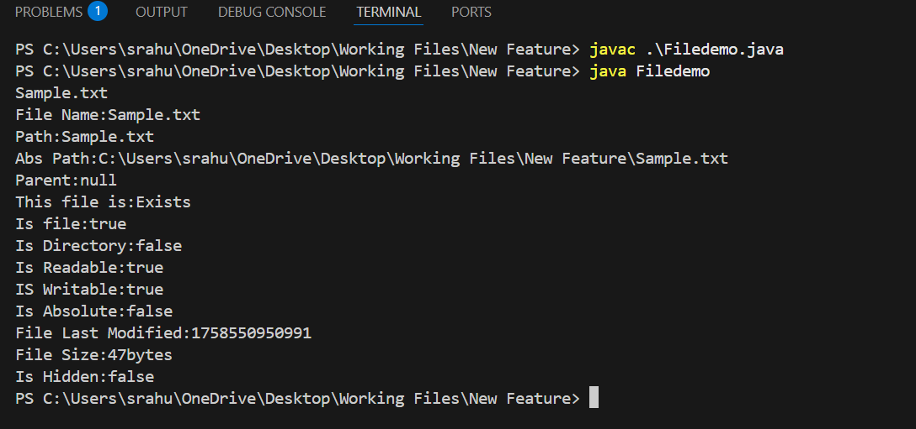

RESULT:
Thus, the program for implementing the file concept has been written and executed successfully.

EXPT: 9A
DATE:

MULTI THREADING
AIM:
To write a Java program to implement the concepts of multithreading.
ALGORITHM:

- Start the program.

- Create a Runnable class even to compute and print the square of a number.

- Create a Runnable class odd to compute and print the cube of a number.

- Create a Thread class A to generate random numbers and manage threads.
- Generate random numbers using the Random class inside the run() method of class A.
- If the generated number is even, create and start a new even thread.

- If the generated number is odd, create and start a new odd thread.

- Pause the main thread for one second after each number and print a separator line.

- In the main() method, create an object of class A, start the thread, and stop the program after execution.

- End the program.

PROGRAM:

package mtherad;
import java.util.*;
class even implements Runnable{
public int x;
public even(int x){
this.x=x;
}
@Override
public void run()
{
System.out.println("Thread Name:Even Thread and square is: " + x * x);

}
}

class odd implements Runnable{
public int x;
public odd(int x){
this.x=x;
}
@Override
public void run()
{
System.out.println("Thread Name:Odd Thread and cube is :"+ x * x * x);

}

}
class A extends Thread{
public String tname;
public Random r;
public Thread t1,t2;
public A(String s){
tname=s;
}
@Override
public void run()
{
int num=0;
r=new Random();
try {
for(int i=0;i<50;i++){
num=r.nextInt(100);
System.out.println("main thread and generated number is"+num);
if(num%2==0)
{
t1=new Thread(new even(num));
t1.start();
}else{
t2=new Thread(new odd(num));
t2.start();
}
Thread.sleep(1000);
System.out.println("------------------------------------");
}
}

catch(InterruptedException ex)
{
System.out.println(ex.getMessage());
}
}
}

public class Mtherad {

public static void main(String[] args) {
A a=new A("one");
a.start();
}
}

OUTPUT:

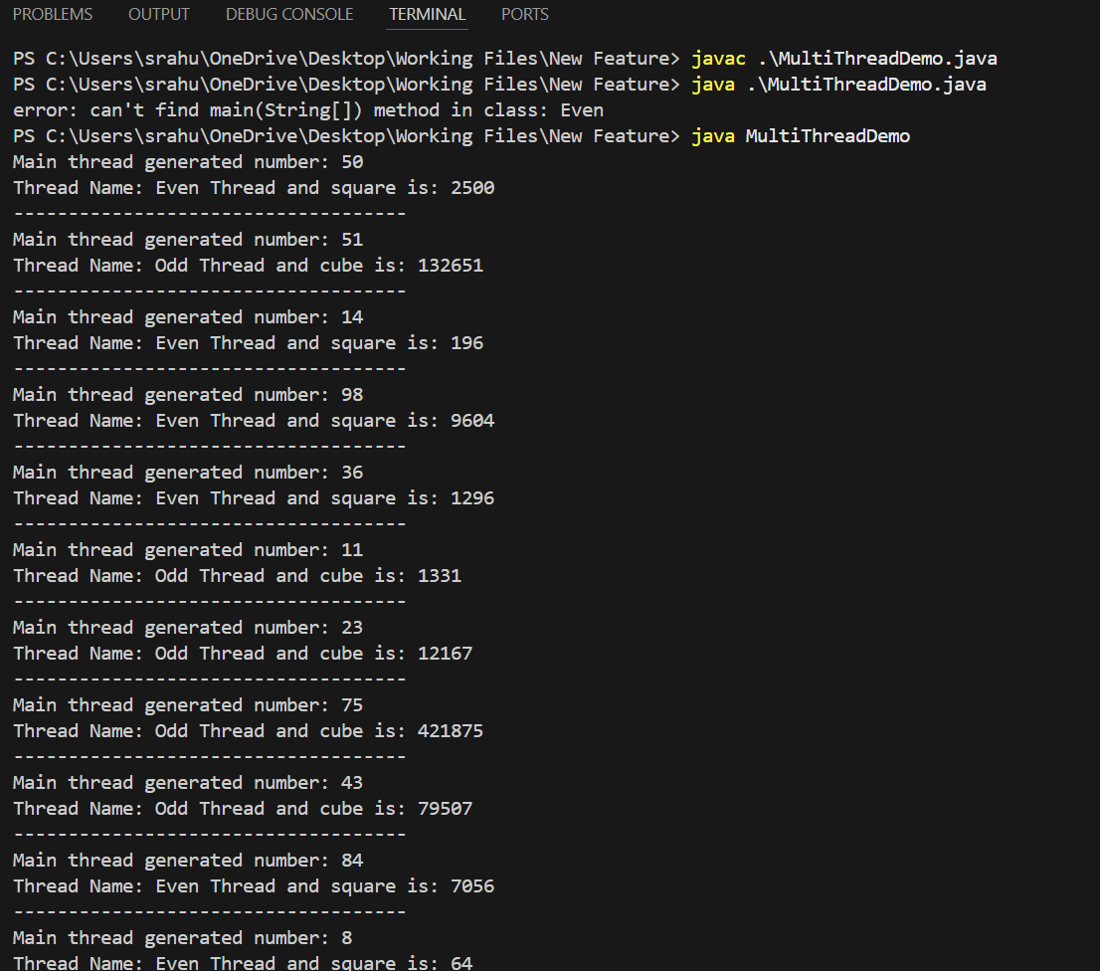

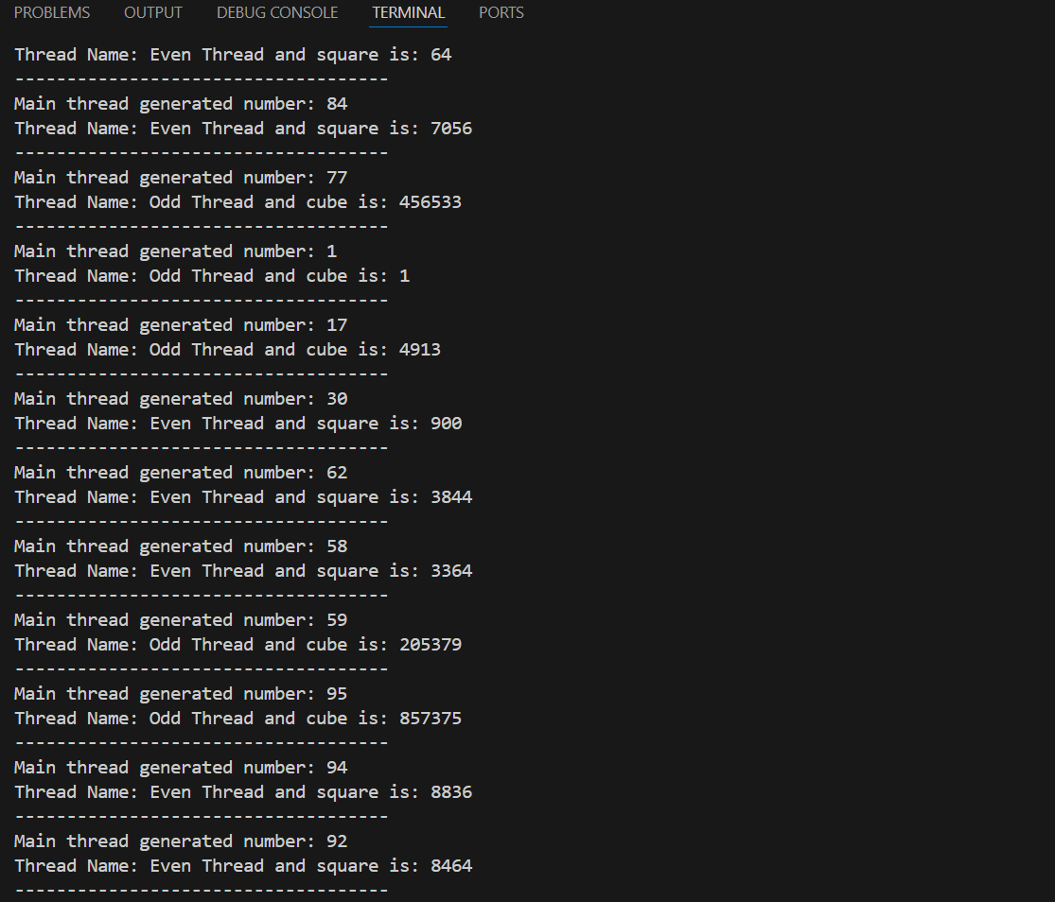

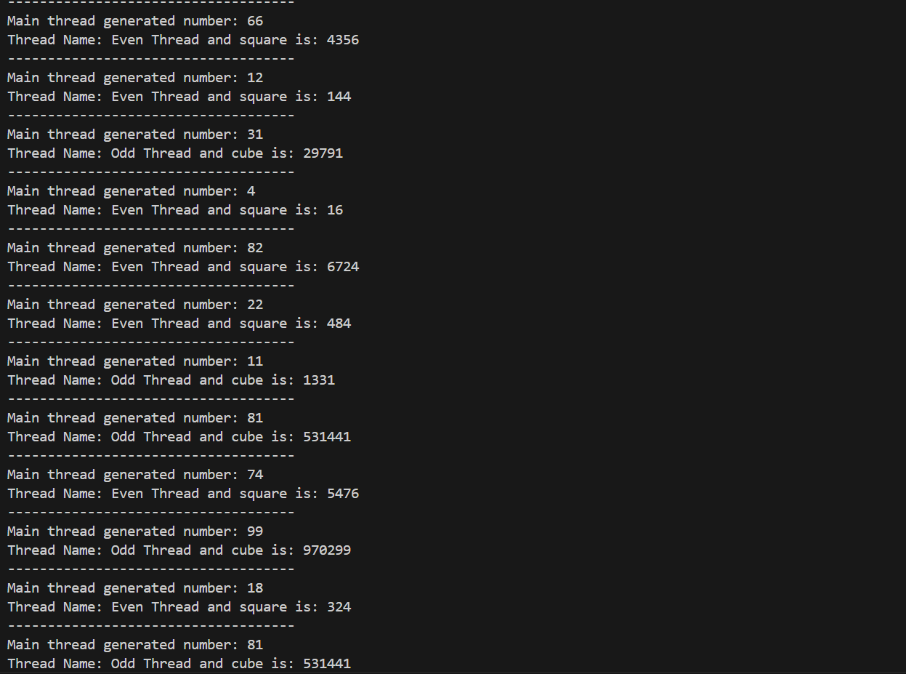

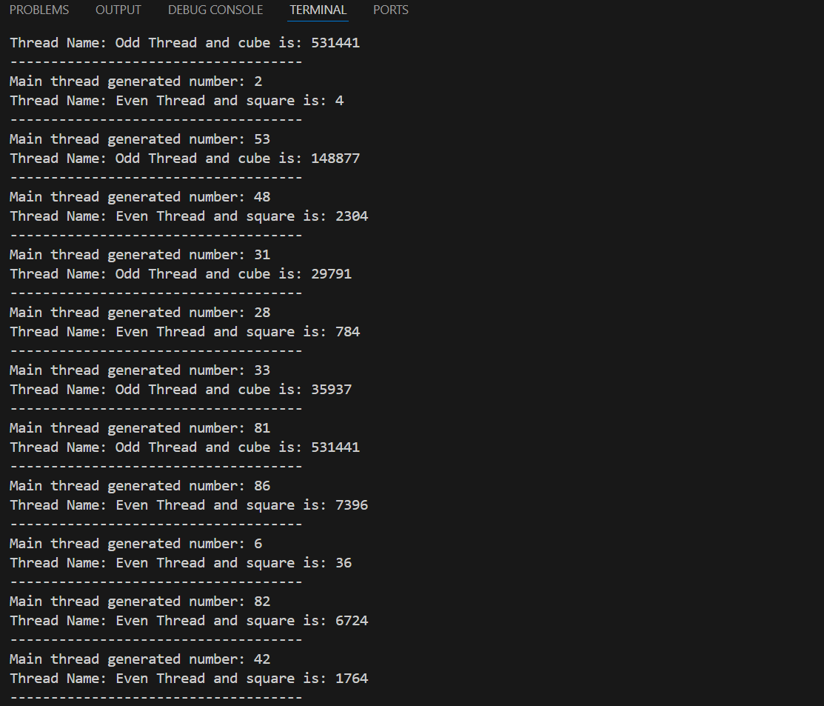

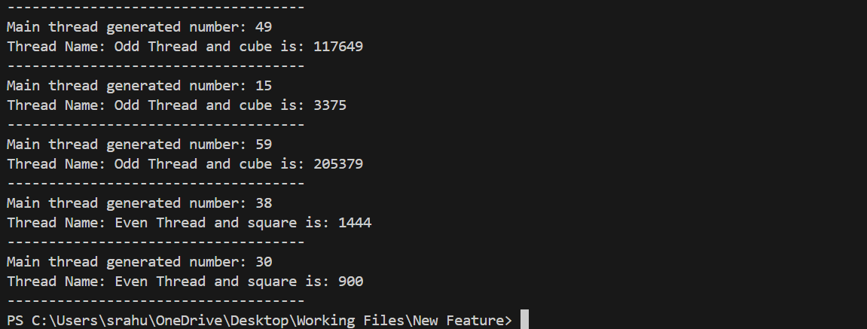

RESULT:

Thus, the program for implementing the concept of multithreading has been written and executed successfully.

EXPT: 9B
DATE:
MULTI-THREADING TO GENERATE RANDOM NUMBER AND COMPUTE SQUARE AND CUBE

AIM:
To write a Java program to implement the concepts of multithreading to generate random number and to compute square if it’s even and compute cube if the number generated is od by implementing Runnable interface and extending Thread.

ALGORITHM:
- Start the program and create a class implementing Runnable to compute the square of even numbers.

- Create another class implementing Runnable to compute the cube of odd numbers.

- Create a thread class A that extends Thread to generate random numbers.

- Initialize a Random object inside class A to generate random integers.
- In the run method of A, generate a random integer between 0 and 49 inside a loop.

- If the generated number is even, create and start a new thread of class even to calculate its square.
- If the generated number is odd, create and start a new thread of class odd to calculate its cube.

- Use Thread.sleep(1000) to pause one second between iterations.

- Display the results from each thread and end the program after generating all numbers.

PROGRAM:

import java.util.Random;
// Thread to compute square of even numbers
class Even implements Runnable {
public int x;
public Even(int a) {
x = a;
}
public void run() {
System.out.println("Thread Name: Even Thread, square is: " + (x * x));
}
}
// Thread to compute cube of odd numbers
class Odd implements Runnable {
public int x;
public Odd(int b) {
x = b;
}
public void run() {
System.out.println("Thread Name: Odd Thread, cube is: " + (x * x * x));
}
}
// Main thread generating random numbers
class A extends Thread {
public Random r;
public Thread t1, t2;
public A(String s) {
super(s); // sets the thread name
}
public void run() {
int num = 0;
r = new Random();
try {
for (int i = 0; i < 20; i++) {
num = r.nextInt(50); // generates random number 0-49
System.out.println("Main Thread generated number: " + num);
if (num % 2 == 0) {
t1 = new Thread(new Even(num));
t1.start();
} else {
t2 = new Thread(new Odd(num));
t2.start();
}
Thread.sleep(1000); // pause 1 second
System.out.println();
}
} catch (InterruptedException ex) {
System.out.println(ex.getMessage());
}
}
}
// Driver class
public class Main {
public static void main(String[] args) {
A a = new A("Generator Thread");
a.start();
}
}

OUTPUT:

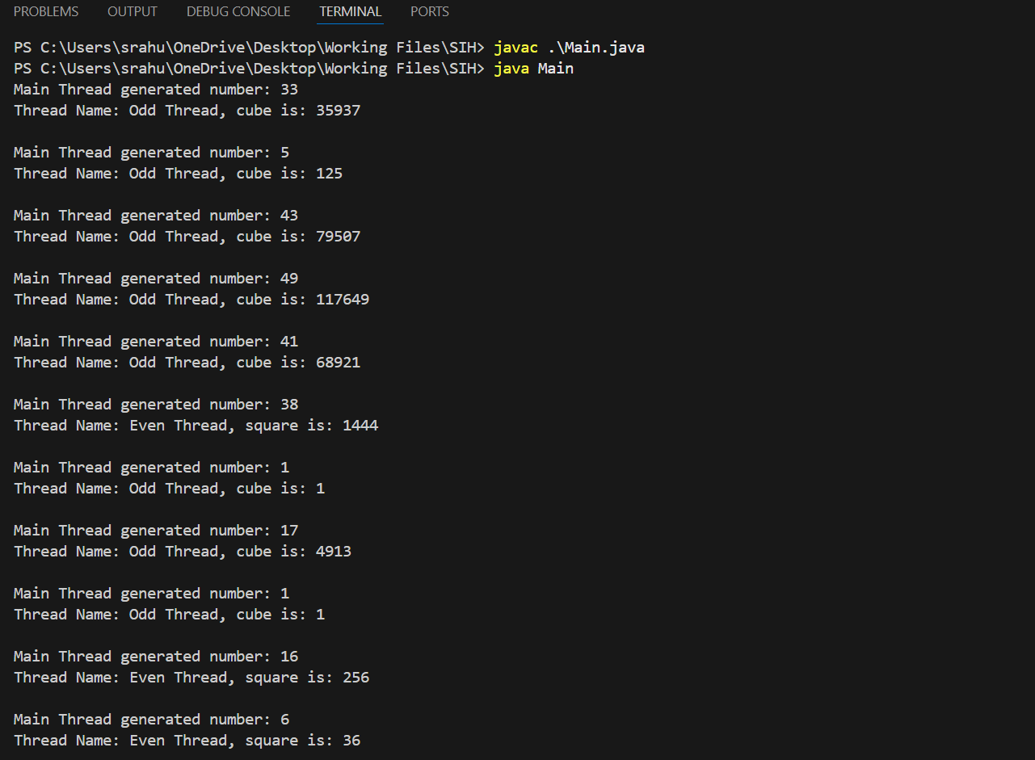

RESULT:

Thus, the program to demonstrate the use of core Collection Framework classes like ArrayList, HashSet, and HashMap has been written and executed successfully.

EXPT: 10
DATE:

COLLECTION FRAMEWORK
AIM:
To write a Java program to demonstrate the use of core Collection Framework classes like ArrayList, HashSet, and HashMap.
ALGORITHM:
- Start the program.

- Create an ArrayList of Strings and add elements including a duplicate..

- Display the ArrayList to show that duplicates are allowed and the order is

maintained.

- Create a HashSet of Strings and add elements including a duplicate.
- Display the HashSet to show that duplicates are ignored and order is not maintained.
- Create a HashMap with integer keys and String values, then add key-value

pairs including a duplicate key.
- Display the HashMap to show that the value of the duplicate key is
overwritten.

- Iterate over the HashMap using a for-each loop and display each key-value

pair.

- End the program.

PROGRAM:

import java.util.*;
public class CollectionFrameworkDemo {
public static void main(String[] args) {
// ----- ArrayList (List interface - Ordered, allows duplicates) -----
System.out.println("---- ArrayList Demo ----");
ArrayList<String> list = new ArrayList<>();
list.add("Apple");
list.add("Banana");
list.add("Cherry");
list.add("Apple"); // Duplicate allowed
System.out.println("ArrayList: " + list);
// ----- HashSet (Set interface - Unordered, no duplicates) -----
System.out.println("\n---- HashSet Demo ----");
HashSet<String> set = new HashSet<>();
set.add("Red");
set.add("Green");
set.add("Blue");
set.add("Red"); // Duplicate ignored
System.out.println("HashSet: " + set);

// ----- HashMap (Map interface - Key-Value pairs) -----
System.out.println("\n---- HashMap Demo ----");
HashMap<Integer, String> map = new HashMap<>();
map.put(101, "John");
map.put(102, "Alice");
map.put(103, "Bob");
map.put(102, "Emma"); // Overwrites value for key 102
System.out.println("HashMap: " + map);

// Iterate over HashMap
System.out.println("\nIterating over HashMap:");
for (Map.Entry<Integer, String> entry : map.entrySet()) {
System.out.println("Key: " + entry.getKey() + ", Value: " + entry.getValue());
}
}
}

OUTPUT:

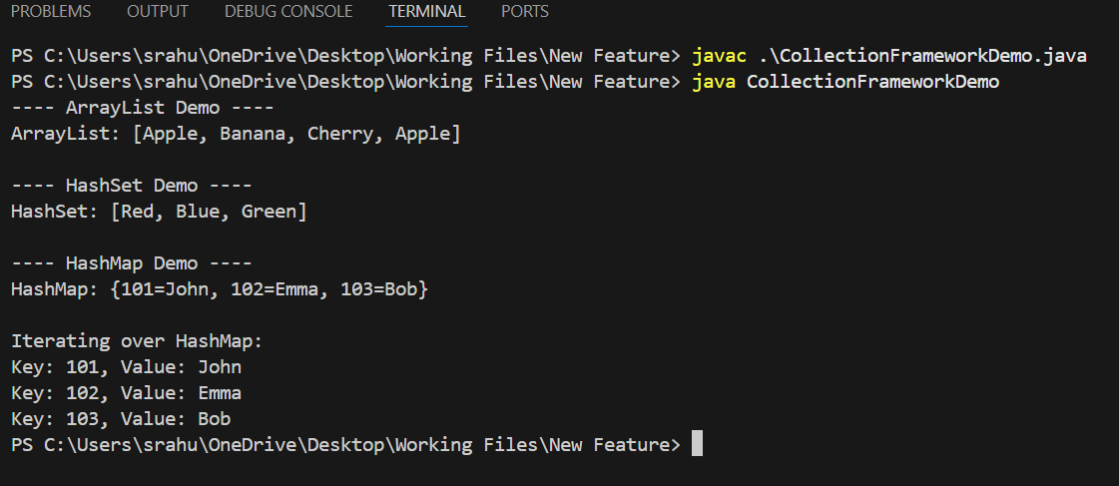

RESULT:

Thus, the program to demonstrate the use of core Collection Framework classes like ArrayList, HashSet, and HashMap has been written and executed successfully.

EXPT: 11
DATE:

JAVAFX CONTROLS, LAYOUTS AND MENUS
AIM:
To write a Java program to develop GUI-based Calculator applications using JavaFX controls, layouts and menus.
ALGORITHM:
- Start the application and create the main stage window using JavaFX.

- Initialize a non-editable text field to display numbers and results aligned to the right.

- Create a grid layout to arrange all calculator buttons for digits, operators, clear, and equals.

- Add event handlers to each button to process the respective input when clicked.
- Append digits and decimal points directly to the display and insert operators with spaces for separation.
- Clear the display and reset state when the clear button is pressed.

- On pressing equals, split the display text into tokens, parse numbers, and perform the respective arithmetic operations.

- Handle division by zero and syntax errors by showing an error message on the display.

- Allow keyboard input for digits, operators, enter for calculation, and delete for clearing, and then display the result or error message.

PROGRAM:

import javafx.application.Application;
import javafx.scene.Scene;
import javafx.scene.control.*;
import javafx.scene.layout.*;
import javafx.stage.Stage;
import javafx.geometry.*;
import javafx.event.ActionEvent;
import javafx.scene.input.KeyCode;
import javafx.scene.input.KeyEvent;

public class JavaFXCalculator extends Application {

private TextField display;
private boolean startNewNumber = true;

public static void main(String[] args) {
launch(args);
}

@Override
public void start(Stage primaryStage) {
display = new TextField();
display.setEditable(false);
display.setAlignment(Pos.CENTER_RIGHT);
display.setPrefHeight(50);

GridPane grid = new GridPane();
grid.setHgap(10);
grid.setVgap(10);
grid.setPadding(new Insets(10));

String[][] buttons = {
{"C", "", "", "", ""},
{"7", "8", "9", "/", ""},
{"4", "5", "6", "*", ""},
{"1", "2", "3", "-", ""},
{"0", ".", "=", "+", ""}
};

for (int row = 0; row < buttons.length; row++) {
for (int col = 0; col < buttons[row].length; col++) {
String label = buttons[row][col];
if (!label.isEmpty()) {
Button btn = new Button(label);
btn.setPrefSize(50, 50);
btn.setOnAction(this::processInput);
grid.add(btn, col, row);
}
}
}

VBox root = new VBox(10, display, grid);
root.setPadding(new Insets(10));

Scene scene = new Scene(root, 310, 320);
primaryStage.setTitle("JavaFX Calculator");
primaryStage.setScene(scene);
primaryStage.setResizable(false);
primaryStage.show();

scene.setOnKeyPressed(this::handleKey);
}

private void processInput(ActionEvent e) {
String value = ((Button) e.getSource()).getText();
if (value.equals("=")) {
calculate();
} else if (value.equals("C")) {
display.clear();
startNewNumber = true;
} else if ("+-*/".contains(value)) {
handleInput(" " + value + " ");
} else {
handleInput(value);
}
}

private void handleInput(String value) {
if (startNewNumber) {
display.clear();
startNewNumber = false;
}
display.appendText(value);
}

private void calculate() {
try {
String[] tokens = display.getText().trim().split(" ");
if (tokens.length < 3) return;

double result = Double.parseDouble(tokens[0]);

for (int i = 1; i < tokens.length; i += 2) {
String op = tokens[i];
double next = Double.parseDouble(tokens[i + 1]);

switch (op) {
case "+":
result += next;
break;
case "-":
result -= next;
break;
case "*":
result *= next;
break;
case "/":
if (next == 0) {
display.setText("Error: Divide by 0");
startNewNumber = true;
return;
}
result /= next;
break;
default:
display.setText("Error");
return;
}
}

display.setText(String.valueOf(result));
startNewNumber = true;
} catch (Exception ex) {
display.setText("Syntax Error");
startNewNumber = true;
}
}

private void handleKey(KeyEvent event) {
String key = event.getText();
KeyCode code = event.getCode();

if ("0123456789.".contains(key)) {
handleInput(key);
} else if ("+-*/".contains(key)) {
handleInput(" " + key + " ");
} else if (code == KeyCode.ENTER || key.equals("=")) {
calculate();
} else if (code == KeyCode.DELETE) {
display.clear();
}
}
}

OUTPUT:

RESULT:
Thus, the Java program to develop GUI-based Calculator applications using JavaFX controls, layouts and menus has been written and executed successfully.

EXPT: 12
DATE:

STUDENT DATABASE MANAGEMENT SYSTEM

AIM:
It provides a common platform to connect student and teacher online. The registered teacher can create Quiz and student can take quiz and can assess himself/herself.

Users of the System
- Teacher
- Student

Functional Requirements
1. Teacher
- Can create quiz after getting logged in!
- Can enter subjects and enter question with its options and answer at the time of creating quiz.
- 10 Question for each quiz required to be completed.
2. Student
- Can search quiz according to their interest.
- Click on the id of quiz and ready to start it just clicking on a button.
- After completing all questions, result will be displayed Automatically.
- Can view the description about each and every question in the respective quiz.

Non-Functional Requirements
- Secure access of confidential data (user’s details). SSL can be used.
- 24 X 7 availability
- Browser testing and support for IE, NN, Mozilla, and Firefox
- Reports exportable in .XLS, .PDF
- Create a detailed UML diagram (Component, Sequence, Class) for the system and its sub-components

User Interface Priorities
- Professional look and feel
- Use of AJAX at least with all registration forms and with every search option and at the id of each searched result with on mouse over event.

Tools to be used
- Use any IDE to develop the project. It may be My eclipse / Eclipse / Netbeanse.
- Oracle 10g for the database.
- Server: Apache Tomcat/JBoss/Glassfish/Web logic/Websphere.

Front End and Back End
- Front End: JSP, JDBC, Javascript, AJAX
- Back End: Oracle
PROCEDURE:
Step 1: Start the Net beans IDE 8.1 . choose File new project java webjava web application
Step 2: Clicknextgive the project namenext.
Step 3: Choose Hibernate 4.3.1click Finish.
Step 4: Edit the contents in index. Html and right click project new servlet
Step 5: Give the class name as quizservlet finish
Step 6: Choose the All programsMySQLMySQL Server 5.7 MySQL Command Client
Step 7: Enter the password as root
Step 8: Create a database using the command
mysql > CREATE DATABASE veena;
Step 9: Create a table in the database using the command
mysql > CREATE TABLE veena.student(seatno int(5),name varchar(20),
total int(5));
Step 10: Right click the librariesAdd jar/folder C:\Program Files\MySQL choose mysql-connectot-java
Step 12: Compile the program and execute it.
Step 13: Stop the program.
PROGRAM
SERVLET CODE:
import java.io.IOException;
import java.io.PrintWriter;
import javax.servlet.ServletException;
import javax.servlet.annotation.WebServlet;
import javax.servlet.http.HttpServlet;
import javax.servlet.http.HttpServletRequest;
import javax.servlet.http.HttpServletResponse;
import java.io.*;
import java.sql.*;
import java.net.*;
import javax.servlet.*;
import javax.servlet.http.*;
/**
*
* @author stud
*/
@WebServlet(urlPatterns = {"/quizservlet"})
public class quizservlet extends HttpServlet {

String msg,seatno,name,ans1,ans2,ans3,ans4,ans5,ans6,ans7,ans8,ans9,ans10;
int total=0;
Connection connect;
Statement stmt =null;
ResultSet rs=null;
@Override
protected void doPost(HttpServletRequest request, HttpServletResponse response) throws IOException
{
try
{
Class.forName("com.mysql.jdbc.Driver");
connect =DriverManager.getConnection("jdbc:mysql://localhost:3306/veena","root","root");
msg="Thank you";
}
catch(ClassNotFoundException cnfex)
{
cnfex.printStackTrace();
}
catch(SQLException e)
{
e.printStackTrace();
}
seatno=request.getParameter("seatno");
name=request.getParameter("name");
ans1=request.getParameter("r0");
ans2=request.getParameter("r1");
ans3=request.getParameter("r2");
ans4=request.getParameter("r3");
ans5=request.getParameter("r4");
ans6=request.getParameter("r5");
ans7=request.getParameter("r6");
ans8=request.getParameter("r7");
ans9=request.getParameter("r8");
ans10=request.getParameter("r9");
if(ans1.equals("four"))
total+=2;
if(ans2.equals("four"))
total+=2;
if(ans3.equals("four"))
total+=2;
if(ans4.equals("four"))
total+=2;
if(ans5.equals("four"))
total+=2;
if(ans6.equals("four"))
total+=2;
if(ans7.equals("four"))
total+=2;
if(ans8.equals("four"))
total+=2;
if(ans9.equals("four"))
total+=2;
if(ans10.equals("four"))
total+=2;
try
{
Statement stmt=connect.createStatement();
String query="INSERT INTO veena.student("+"seatno,name,total"+")VALUES('"+seatno+"','"+name+"','"+total+"')";
int result=stmt.executeUpdate(query);
stmt.close();
}
catch(SQLException e1)
{
}
response.setContentType("text/html");
PrintWriter out =response.getWriter();
out.println("<html><body><center>");
out.println("<h1>"+msg+"</h1>\n");
out.println("<h3>Your result is "+"</h3></br>");
out.println("<table border=2>");
try
{
Statement stmt =connect.createStatement();
String query ="SELECT * FROM student";
rs=stmt.executeQuery(query);
out.println("<th>"+"seatno"+"</th>");
out.println("<th>"+"name"+"</th>");
out.println("<th>"+"marks"+"</th>");
while(rs.next())
{
out.println("<tr>");
out.println("<td>"+rs.getInt(1)+"</td>");
out.println("<td>"+rs.getString(2)+"</td>");
out.println("<td>"+rs.getString(3)+"</td>");
out.println("</tr>");
}
out.println("</table>");
}
catch(SQLException ex)
{
}
finally
{ try
{
if(rs!=null)
rs.close();
if(stmt!=null)
stmt.close();
if(connect!=null)
connect.close();
}
catch(SQLException e)
{

}
}
out.println("</center>");
out.println("</body></html>");

}
}
HTML CODE:
<html>
<head>
<title>Quiz></title>
</head>
<body>
<h2>Hello , Welcome to Quiz!</h2>
<form name="frm" action="quizservlet" method="post">
Seat no:<input type="text" name="seatno" />
Name:<input type="text" name="name" />
<h2>Hello , Welcome to Quiz!</h2>
<p>1.What is HTML?</p><br />
<input type="radio" name="r0" value="one"/>Highlevel makeup language<br/>
<input type="radio" name="r0" value="two"/>HyperText Makeup language<br/>
<input type="radio" name="r0" value="three"/>Highlighter markup language<br/>
<input type="radio" name="r0" value="four"/>Hypertext markup language<br/>
<p>2.What is XML</p><br />
<input type="radio" name="r1" value="one"/>Extendable Markup Language<br/>
<input type="radio" name="r1" value="two"/>Extensible Makeup Language<br/>
<input type="radio" name="r1" value="three"/> Extension of Markup Language<br/>
<input type="radio" name="r1" value="four"/>Extensible Markup Language<br/>
<p>3.What is DOM?</p><br />
<input type="radio" name="r2" value="one"/>Domain Object Model <br/>
<input type="radio" name="r2" value="two"/>Domains Object Model<br/>
<input type="radio" name="r2" value="three"/>Domain Of Model <br/>
<input type="radio" name="r2" value="four"/>Document Object Model<br/>
<p>4.What is DHTML ?</p><br />
<input type="radio" name="r3" value="one"/>Dynamic of HTML<br/>
<input type="radio" name="r3" value="two"/>Digital HTML<br/>
<input type="radio" name="r3" value="three"/>Direct Link<br/>
<input type="radio" name="r3" value="four"/>Dynamic HTML<br/>
<p>5.What is the name of code used for color</p><br />
<input type="radio" name="r4" value="one"/> MMM<br/>
<input type="radio" name="r4" value="two"/>GRB<br/>
<input type="radio" name="r4" value="three"/>DFR <br/>
<input type="radio" name="r4" value="four"/>RGB<br/>
<p>6.What is INFITT </p><br />
<input type="radio" name="r5" value="one"/>International Forum For Information Technology <br/>
<input type="radio" name="r5" value="two"/>International Forum For Information Technology in Telugu<br/>
<input type="radio" name="r5" value="three"/>International Forum For Information Transfer in Tamil <br/>
<input type="radio" name="r5" value="four"/>International Forum For Information Technology in Tamil<br/>
<p>7.The Additional Info given to a tag is </p><br />
<input type="radio" name="r6" value="one"/>Objects <br/>
<input type="radio" name="r6" value="two"/>Container<br/>
<input type="radio" name="r6" value="three"/>Sub Tag <br/>
<input type="radio" name="r6" value="four"/>Attributes<br/>
<p>8.Loop can be used with which tag ?</p><br />
<input type="radio" name="r7" value="one"/>input<br/>
<input type="radio" name="r7" value="two"/>img<br/>
<input type="radio" name="r7" value="three"/>bgcolor<br/>
<input type="radio" name="r7" value="four"/>bgsound<br/>
<p>9.Tag for creating line is </p><br />
<input type="radio" name="r8" value="one"/>lb<br/>
<input type="radio" name="r8" value="two"/>line<br/>
<input type="radio" name="r8" value="three"/>br<br/>
<input type="radio" name="r8" value="four"/>hr<br/>
<p>10.face attibute is for which tag</p><br />
<input type="radio" name="r9" value="one"/>bgsound<br/>
<input type="radio" name="r9" value="two"/>img<br/>
<input type="radio" name="r9" value="three"/>marquee <br/>
<input type="radio" name="r9" value="four"/>font<br/>

<input type="submit" value="submit answer" >
</form>
</body>
</html>
OUTPUT:
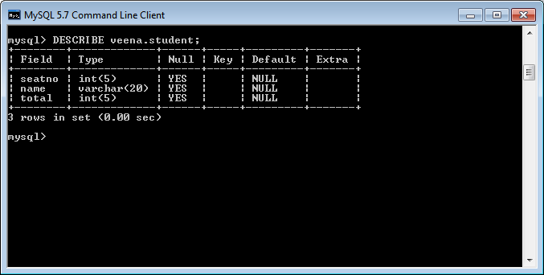

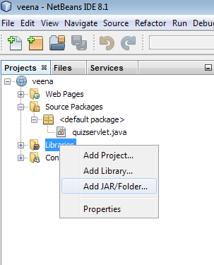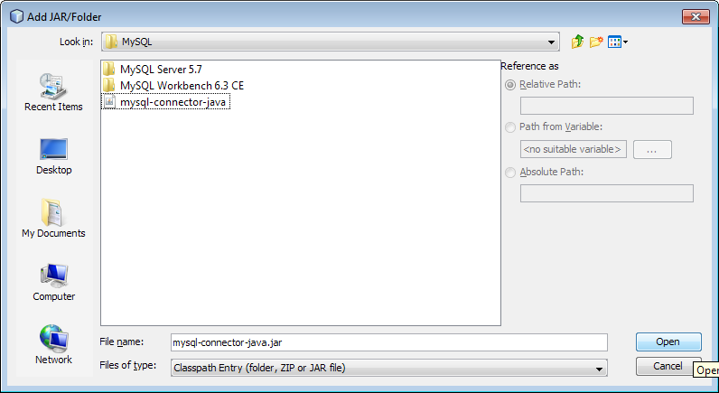

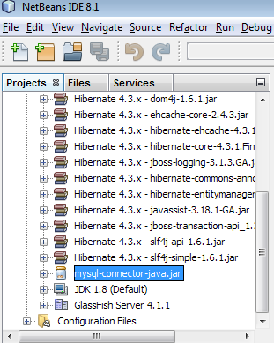
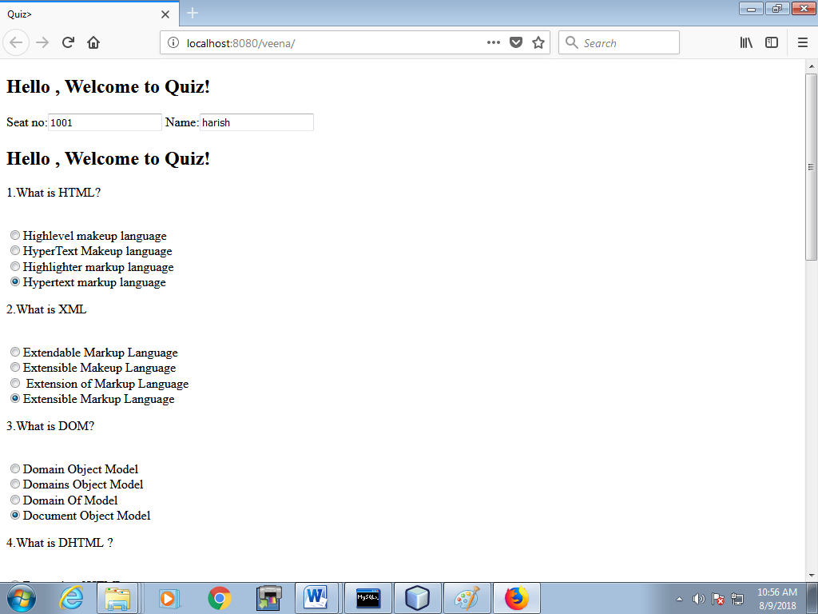

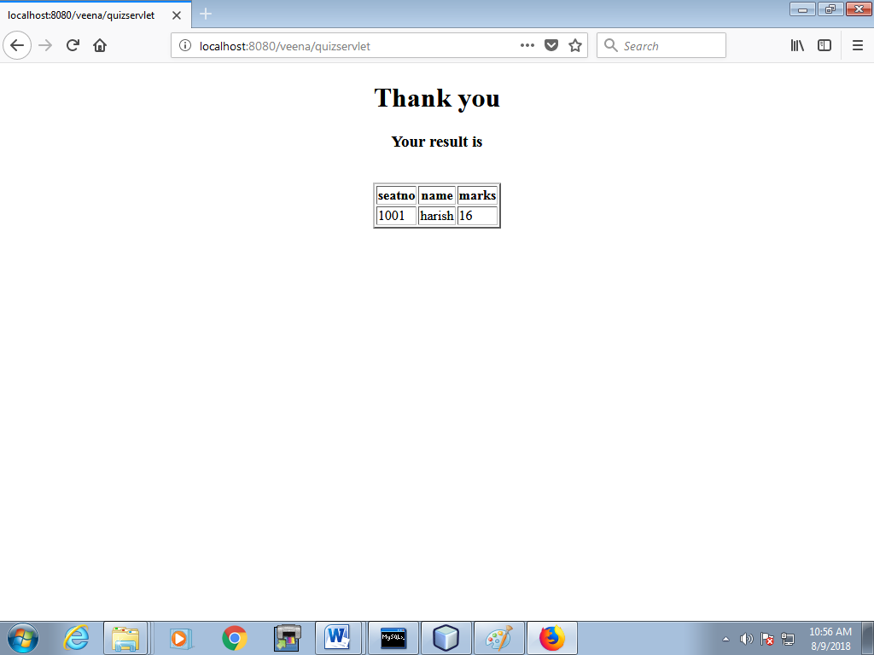

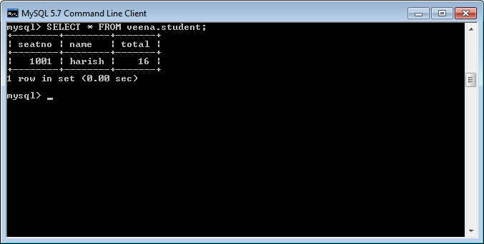

RESULT:
Thus, a simple student database management system using event-driven and concurrent programming paradigms of Java using JDBC to connect a back-end database has been executed successfully.

